

ST. RITA’S COLLEGE OF BALINGASAG, INC.

Balingasag, Misamis Oriental 9005

Email: ritarian@srcb.edu.ph Website: srcb.edu.ph

Tel. (088)323-7159/ Mobile: +63-929-734-0012 (SMART); +63-975-637-9948 (Globe)

PAASCU LEVEL II: Higher Education

(Philippine Accrediting Association of Schools, Colleges and Universities)

PROJECT PROGRESS REPORT

ARDUINO: SMART TRASHBIN

Group 3
Members:
Hanz Mathew W. Manaiz
Janrey E. Guco
Kyle Valmorida
Lemjohn Edelion
Vincent Galamiton
Justine Ravida

Submitted to:
Odemil A. Uyan

FEBRUARY 2026

l. Project Overview

The Smart Trashbin Arduino Project is an automated waste disposal system designed to promote hygiene and convenience. The main objective of this project is to create a touchless trash bin that automatically opens its lid when a person’s hand or object is detected nearby.
The system uses an Arduino microcontroller, an ultrasonic sensor to detect distance, and a servo motor to control the lid movement. By minimizing physical contact, the project helps reduce the spread of germs and encourages proper waste disposal in homes, schools, and public areas.

ll. Current Status
So far, the following components and features have been completed:
Hardware Setup
- Arduino board connected and powered properly
- Ultrasonic sensor wired for distance detection
- Servo motor connected for lid movement
- Breadboard and jumper wires organized correctly
Programming
- Basic Arduino code uploaded successfully
- Ultrasonic sensor can measure distance accurately
- Servo motor rotates when an object is detected within the set range
- Lid automatically closes after a few seconds
Initial Testing
- System responds to hand detection
- Opening and closing mechanism works
- Basic troubleshooting completed
- The trash bin is functional but still needs improvements in stability and design.
Ill. Challenges & Solutions
Challenge 1: Inconsistent Distance Detection
At first, the ultrasonic sensor gave unstable readings.
Solution:
We adjusted the sensor angle and added slight delays in the code to stabilize the readings.
Challenge 2: Servo Motor Not Moving Properly
The servo motor sometimes did not rotate smoothly.
Solution:
We checked the wiring connections and ensured proper power supply. We also adjusted the servo angles in the code to avoid over-rotation.
Challenge 3: Jumper M-to-M Wire Connection Issues
We experienced loose connections using male-to-male (M-to-M) jumper wires, which caused the system to randomly stop working or the servo to malfunction.

Solution:
We secured the jumper wires firmly into the breadboard and Arduino pins. We also replaced some worn-out jumper wires and rearranged the wiring layout to prevent accidental disconnections.

To complete the project, the following tasks remain:
- Improve wiring for cleaner presentation
- Add a protective casing for the Arduino and components
- Test the system for long-term durability

lV. Future Improvements:
LCD display for status messages
Buzzer sound when the lid opens
Trash level detection sensor
Once these improvements are completed, the Smart Trashbin will be fully functional, reliable, and ready for demonstration.

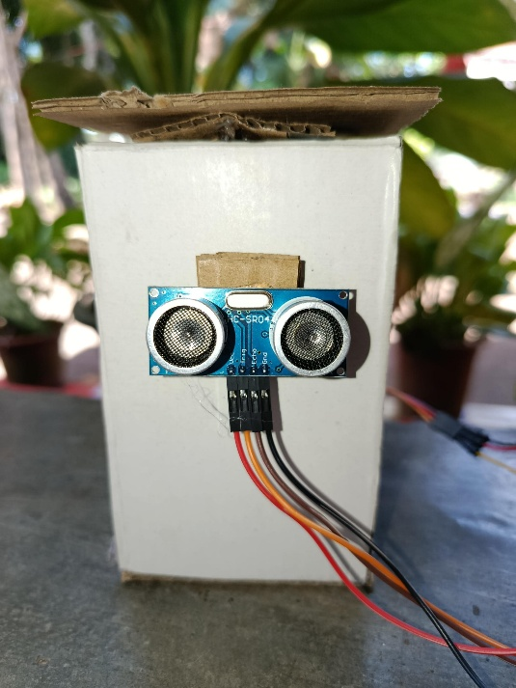
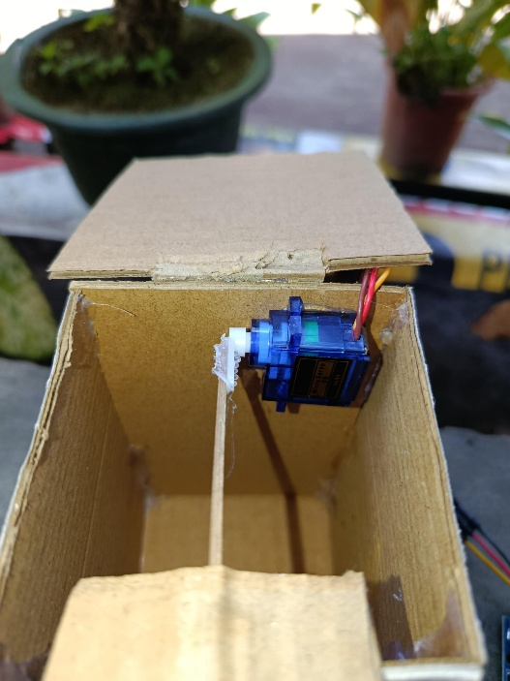
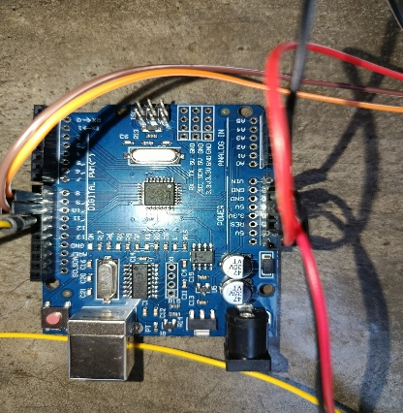
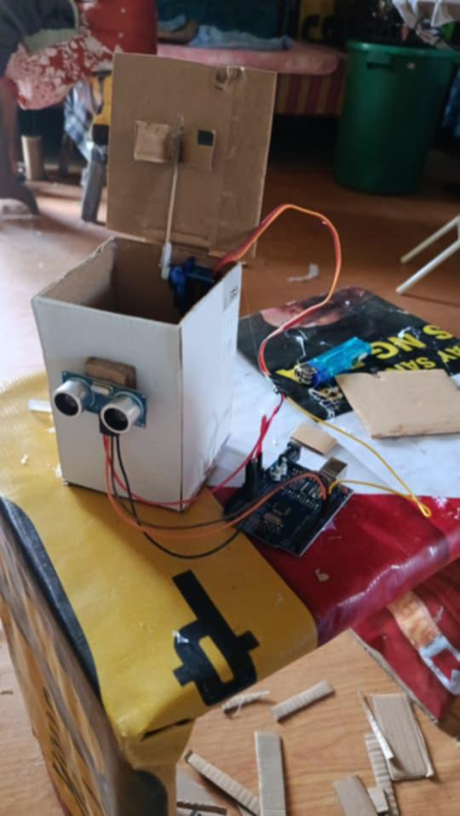
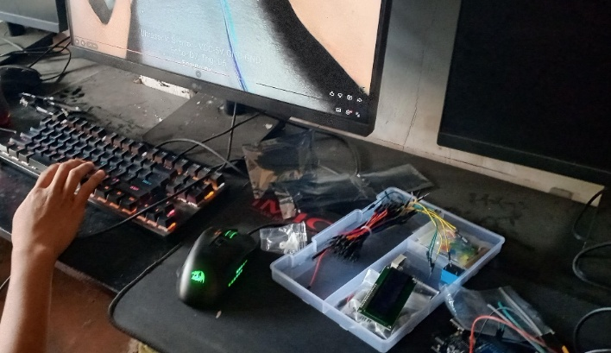
Documentation:
